Question ist=[{product_id:321,barcode_id:123,product_name:'vnfdhdh',volume:2.0,price:50.0,barcoded:null,

primaryCategory:{category_id:1,category_name:'fruits'}},

{product_id:321,barcode_id:123,product_name:'vnfdhdh',volume:2.0,price:50.0,barcoded:null,

primaryCategory:{category_id:1,category_name:'fruits'},}

];

Solution 1

var list=[{product_id:321,barcode_id:123,product_name:'vnfdhdh',volume:2.0,price:50.0,barcoded:null,

primaryCategory:{category_id:1,category_name:'fruits'}},

{product_id:321,barcode_id:123,product_name:'vnfdhdh',volume:2.0,price:50.0,barcoded:null,

primaryCategory:{category_id:1,category_name:'fruits'},}

];

var obj2 =list.map((item,index) =>{

return{

...item,

...item.primaryCategory,}

})

console.log(obj2);

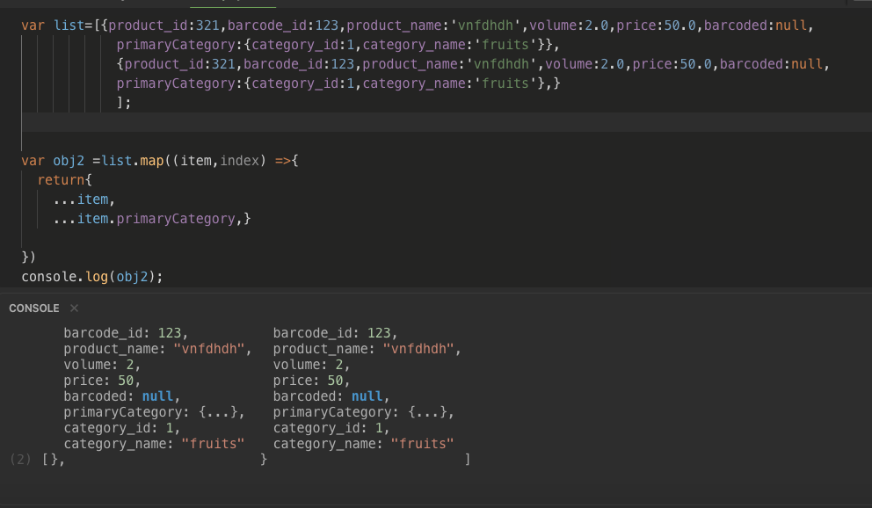

Solution 2

var list=[{product_id:321,barcode_id:123,product_name:'vnfdhdh',volume:2.0,price:50.0,barcoded:null,

primaryCategory:{category_id:1,category_name:'fruits'}},

{product_id:321,barcode_id:123,product_name:'vnfdhdh',volume:2.0,price:50.0,barcoded:null,

primaryCategory:{category_id:1,category_name:'fruits'},}

];

var obj2 =list.map((item,index) =>{

return{

...item,

...item.primaryCategory,}

})

obj2.map((x,key)=>{

// console.log(key);

delete x.primaryCategory;

})

console.log(obj2

);

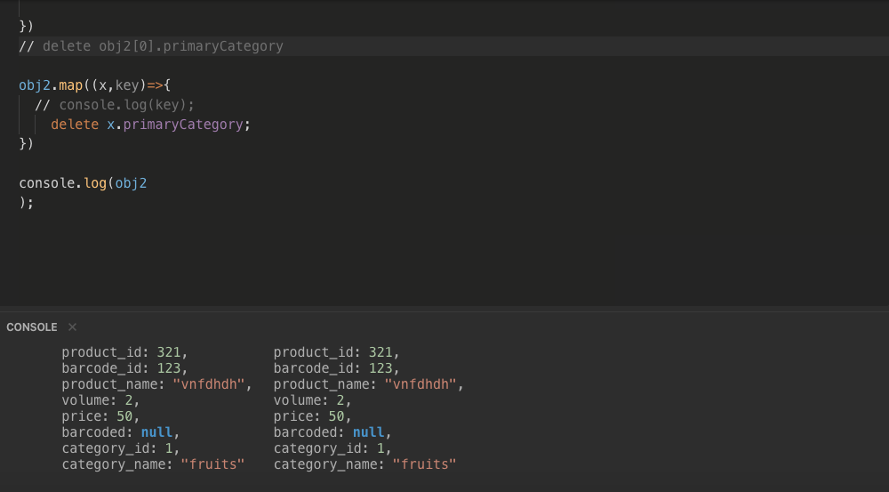

Solution 3

var list=[{product_id:321,barcode_id:123,product_name:'vnfdhdh',volume:2.0,price:50.0,barcoded:null,

primaryCategory:{category_id:1,category_name:'fruits'}},

{product_id:321,barcode_id:123,product_name:'vnfdhdh',volume:2.0,price:50.0,barcoded:null,

primaryCategory:{category_id:1,category_name:'fruits'},}

];

var obj2 =list.map((item,index) =>{

return{

...item,

...item.primaryCategory,}

})

delete obj2[0].primaryCategory

delete obj2[1].primaryCategory

// obj2.map((x,key)=>{

// // console.log(key);

// delete x.primaryCategory;

// })

console.log(obj2);

